Making a horizontal sundial
To make a horizontal sundial you need a gnomon (a pointer with an angle equal to your latitude) and a horizontal scale. You will also need a compass to set your gnomon and scale so that it lines up with the north-south line where you are.

The horizontal, scale should look like the one drawn below. The lines show the hours. This one is correct for a person at 51º N, you will have to use the table below to draw your own if you live at another latitude.
12
3
2
1
11
9
8
10
6
5
4
6
7
Sundial face - horizontal
θ

The gnomon
You can use these to make a sundial that should be accurate for 51º N.
The gnomon goes along the centre line of your dial face and the thickness of this line should be the same as the width of the gnomon.
51º

The table below shows the angle θ for different hours at various latitudes

Hours from noon | 50 | 51 | 52 | 53 | 55
0 | 0.0 | 0.0 | 0.0 | 0.0 | 0.0
1 | 11.6 | 11.8 | 11.9 | 12.1 | 12.4
2 | 23.8 | 24.2 | 24.5 | 24.7 | 25.3
3 | 37.4 | 37.8 | 38.2 | 38.6 | 39.3
4 | 53.0 | 53.4 | 53.8 | 54.1 | 54.8
5 | 70.7 | 71.0 | 71.2 | 71.4 | 71.9
6 | 90.0 | 90.0 | 90.0 | 90.0 | 90.0

The angle from the noon line (12:00) is called the hour angle (H). Since the Sun moves through 15º each hour the hour angle is 15 x the number of hours from noon.

You can calculate the angle (θ) from the noon line for various hours using your latitude (L).

θ = tan ^{–1}[sin L x tan H]

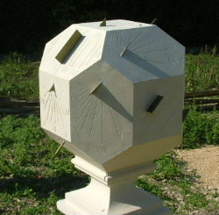
Don't forget to change the angle of your gnomon to that of your latitude
A mulitifaced sundial in a village in France

