EXPERIMENTS ABOUT AIR PRESSURE

wooden lath
newspaper
Experiment One
You will need a large sheet of newspaper and a thin wooden lath (hardboard works well). Put the lath half on the table and cover it with the newspaper. Make sure that the newspaper is smoothed flat.
Push the lath down slowly. What happens?
Put the lath back and smooth the newspaper. Now hit the lath hard and quickly. What happens and why?

Experiment Two
You will need a milk bottle full of water and a sink.
Simply upturn the bottle over the sink and record exactly what happens to the water.
Why does the water move in this way?

Experiment Three
You will need a milk bottle, a table tennis ball and water. Fill the milk bottle to the brim with water. Slide the table tennis ball onto the top of the jar making sure that there are no air bubbles in the water.
Now turn the jam jar upside down. Record and explain what happens.

Experiment Five
You will need plastic bottle fitted with a stopper and a long rubber tube, some water and a bucket.
Fill the bottle with water. Push the stopper in, and hold the end of the tube closed.
Get up on a stool, hold the bottle above your head and get a friend to put the end of the tube in the bucket. Open the bottom end of the tube.

What happens? Why?

Experiment Four.
You will need a rubber sucker and a Newton-meter.
Fix the sucker to the desk.
Try and pull it off with the Newton-mete.
Record the force needed to pull it off.
Work out the pressure from:
Pressure = Force/Area

This sheet is for the teacher and technician only

Apparatus required:

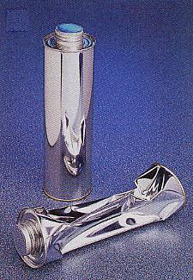
Crushing can
Magdeburg hemispheres
Bucket
Newspaper
Wooden laths (one for each pupil)
Bunsen burner
Rubber sucker (6)
Newton meter (6)
Milk bottle (4)
Table tennis balls (4)
Large plastic drinks bottle
Rubber tube
Short glass tube
Rubber stopper

Comments on the experiments :

Extension demonstration experiments

Experiment Six
You will need two Magdeburg hemispheres and a vacuum pump.
Put the two hemispheres together and see how easy it is to pull them apart.
Now pump the air out of them and try and pull them apart.

See the Creative Teaching Ideas (atmospheric Pressure) for the following (and other) further suggestions).

Experiment Seven
!
Crushing can

Experiment Eight
Balloon in Bell Jar

Experiment Nine
Drinks can and cold water

The photographic images are the copyright of Philip Harris Education and no part of them may be reproduced, photocopied or stored in any data retrieval system without permission.

