Density Name: ……………………………………

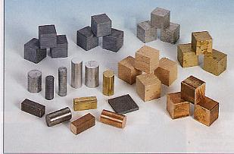
The aim of this experiment is to help you measure the density of some regular and irregular shaped objects

YOU WILL NEED
A number of regular shaped blocks, some irregular shaped objects, some cotton, a balance, a measuring jug or a displacement can and a measuring cylinder, water, a ruler

WHAT TO DO
1. Regular shaped objects
Take one of the regular shaped objects and use the balance to measure its mass in grams. Now use the ruler to measure its length, width and height in centimetres.
Write down your results in the table.

Material | Mass  (gms) | Length  (cm) | Width  (cm) | Height  (cm) | Volume  (cm³) | Density  (g/cm³)

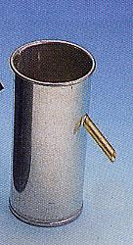
2. Irregular shaped objects
Take one of the irregular shaped objects and use the balance to measure its mass in grams. Put some water into the measuring jug up to a known level. Tie it to a piece of cotton to the object and lower it into the water so that it is completely below the surface. See how much the water level rises – this is the volume of the object.
Write down your results in the table.

Material | Mass (gms) | Volume (cm³) | Density (g/cm³)

Work out the density of each material using the formula:

Density = mass/volume

You could use a displacement can and a measuring cylinder instead of a measuring jug

This sheet is for the teacher and technician only

Apparatus required:

Displacement vessel
Measuring jug
Measuring cylinder
Cotton
Ruler
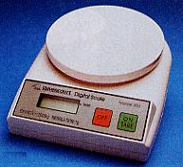
Set of regular objects
Top pan balance

Comments on the experiment:

The jug and/or measuring cylinder must be big enough to accommodate the irregular shapes.
Ask the children how they would deal with an object that floated.

The photographic images are the copyright of Philip Harris Education and no part of them may be reproduced, photocopied or stored in any data retrieval system without permission.

