Forces in liquids

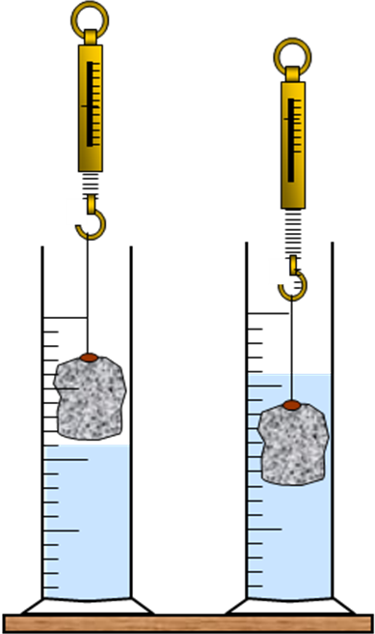
AIM
The aim of this experiment is to investigate how the weight of something seems to change when it is in a liquid.

WHAT TO DO

Fix the stone to the Newton-meter as shown in the diagram.

Measure the weight in air
Lower it into the liquid
Measure the weight in the liquid

Weight of the stone in the air = N
Weight of the stone in liquid = N

Two members of the group should use water and the other two should use oil.

Compare the results of the two halves of the group.

Discuss between yourselves what this means about the density of the two liquids.

Divide the time so that one member of the group can find look up a formula to give the density of the stone relative to water. Another member should find out how your results can be explained by Archimedes principle.

