THE PRINCIPLE OF THE TRANSFORMER

These two experiments should help you understand something about the transformer.
iron C cores and clip
primary and secondary (10 turns)
1.5 V cell
100 μA meter

Experiment One.
You will need, two iron C cores, 2 one metre lengths of insulated wire, a 1.5V cell, a clip, a variable resistor and a 0 – 100 μA meter.

Instructions.
Set up the apparatus as shown in the diagram. There should be ten turns on each coil.
Connect one coil to the galvanometer and record what happens to the meter reading when:-
(i) the other coil is connected to the 1.5 V cell
(ii) the other coil has a steady current flowing in it
(iii) the other coil is disconnected
Now connect the variable resistor in series with the cell and the cell coil. Vary the resistance quickly and record what happens to the meter reading.
Write up the experiment in your books.
mounted bulb
high current power supply (1 V a.c)
iron C cores and clip
primary and secondary (10 turns)
Experiment Two.
You will need similar apparatus to the first experiment, but a high current power supply and a bulb in place of the cell and meter.

Instructions.
Connect the apparatus as shown with one coil fixed to the 1 V AC output of the power supply. Record what happens to the bulb.
Now try reducing the number of turns on the secondary, and then reducing the number of turns or the primary. What happens to the bulb in each case? Describe and explain what happens if the C cores are slightly separated.

Write up the experiment in your books.

This sheet is for the teacher and technician only

Apparatus required:
Two iron C cores and C core clip
2 one metre lengths of insulated wire
1.5V cell
Variable resistor
0 - 100 μA centre zero meter
High current power supply
Mounted 2.5 V bulb

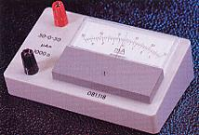
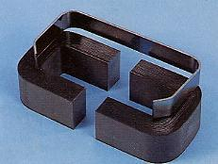

Comments on the experiments:

You will need to warn the pupils that the deflections obtained on the meter in Experiment 1 are really small.

The photographic images are the copyright of Philip Harris Education and no part of them may be reproduced, photocopied or stored in any data retrieval system without permission.

