Crumple zones

AIM:
The aim of this experiment is to study the affect of crumple zones in a collision
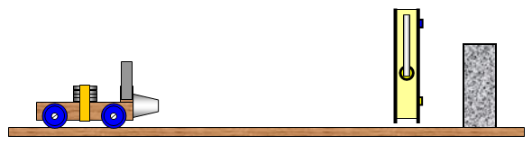
YOU WILL NEED
1. Trolley, heavy concrete building block to act as a stopping wall, motion sensor, runway, various types of ‘crumple’ zones that can be fixed to the front of the trolley.
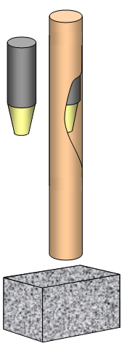
2. Trolley, heavy concrete block, cardboard tube about 1.5m long, metal cylinder with a diameter just less than that of the tube, metre ruler, various types of ‘crumple’ zones that can be fixed to the cylinder

WHAT TO DO
1. Set the runway at an angle and allow the trolley to run down it so that it collides with the block.
Repeat the experiment with different shaped crumple zones and with some of different materials. Always start with the trolley at the same distance away from the block up the slope.
If required measure the speed of the trolley just before the crumple zone hits the block using a light gate and suitable interface or a motion sensor.

If a linear air track is available this would make the experiment more accurate.

Damage to people in a car in a collision is due to how quickly they decelerate. A long, slow deceleration will cause less injury that a short, rapid one.

2. An alternative experiment is to drop a metal cylinder down a cardboard tube. The diameter of the cylinder should be almost as great as that of the tube. The crumble zone under test is fitted to the lower end of the cylinder and should be a little smaller than that of the cylinder to allow for sideways deformation.

Place the block under the tube with a gap slightly longer than the length of the cylinder and crumple zone

When the crumple zone hits the concrete block it will deform and the amount (length) of deformation can be measured.

As in the first experiment all the crumple zones should be of the same initial length.

If required the speed (v) at which the cylinder (crumple zone) hits the floor (a solid block) can be found from v = (2gh)^{1/2} where h is the high fallen and g is the acceleration due to gravity (10 m/s²).

