FLOW OF ELECTRICAL CHARGE

(DEMONSTRATION ONLY)

AIM:
The aim of this experiment is to investigate the velocity of charged ions in an electric field. This is of the same order as the drift velocity of electrons in a wire under the influence of the same field.
+50 -100V
crocodile clip
microscope slide
filter paper
0 V
crystal

YOU WILL NEED:
HT power supply (50 – 100 V) current limited to 5 mA. Two digital meters (for use as a voltmeter and a milliammeter). Microscope slide. Retort stand etc. Two crocodile clips. Leads. Filter paper. Scissors. Potassium permanganate crystals. Ammonium hydroxide solution. Stop clock. 30 cm rule. Wooden block.
Two optical pins

WHAT TO DO:
Connect an HT supply with its output current limited to 5 mA across the pins, soak the filter paper with ammonium hydroxide and place a potassium permanganate crystal in the centre of the paper. Apply a potential difference of 75 V between the crocodile clips and measure the time it takes for the purple colour to travel 1 cm. Doing the whole experiment on a plastic strip with a half millimetre scale marked on it helps, and using a TV camera to view the whole slide on a screen helps even more.

The milliammeter is used simply to check that the current is not too large, it must be limited to a maximum of 5 mA.
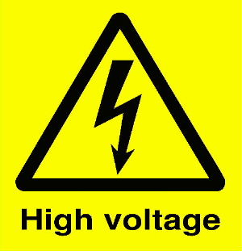

150 V
V
mA
Demonstration only. Ammonia solution (ammonium hydroxide) is corrosive and releases ammonia gas which may cause respiratory disorders especially to asthmatics. HT units must be under careful control and the voltage limited to the maximum required to produce a result with their output current limited to 5 mA. Do not touch the exposed crocodile clips or pins.

Repeat this for a series of voltages between 75V and 100V.

ANALYSIS AND CONCLUSIONS:

Calculate the velocity of the ions for a series of values of the HT voltage.

Plot a graph of ion velocity against voltage. (A graph of ion velocity against electric field (V/d) is even better)

