AMPERE BALANCE

AIM:
The aim of this experiment is to determine the value of the permeability of free space (μ_{o}).
0 -12V DC
d
small coil
large coil
rider
A

YOU WILL NEED:
An Ampere balance, leads, a ruler, a variable low voltage power supply, an ammeter, a balance to measure the mass of the rider (accuracy 0.1 gm)

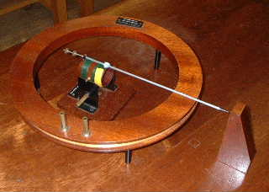
WHAT TO DO:
The small coil (area A) is pivoted on a horizontal axis which passes through the centre of the large coil (radius R).

The apparatus should be set up with the two coils connected in series. Adjust the balance screws and the rider on the small coil until the pointer fixed to it is perfectly horizontal as shown by the vertical scale. Pass a known current I through the coils and adjust the position of the rider to bring the pointer back to the horizontal once more.

Record the current (I), mass of rider (m), the distance the rider has to be moved (d), the radius of large coil (R), the number of turns on the small and large coils (n and N) respectively and the radius of the small coil (r).

THEORY:
The field at the centre of the large coil (N turns) is given by

B = μ_{o}NI/2R

and due to this the small coil (n turns) will experience a torque BAnI, which may be balanced by an opposing torque mgd, where d is the distance that the rider has to be moved to rebalance the pointer.

Therefore mgd = [μ_{o}NI/2R] AnI = = μ_{o}nNAI²/2R and hence μ_{o} may be found.

ANALYSIS AND CONCLUSIONS:
Calculate the value of μ_{o} from the equation:

mgd = μ_{o} [NIAnI]/2R where A is the cross sectional area of the small coil.

Comment on the accuracy of your value.

NOTES:
It is likely that this apparatus is no longer available form the major apparatus suppliers. However it should be possible to construct one without too much difficulty. The DT department in the school would find this a challenging project and one suitable for an older student's project.

