BETA RAY ABSORPTION

DANGER. BETA RADIATION. TAKE SENSIBLE PRECAUTIONS. RETURN SOURCES TO A MEMBER OF STAFF IMMEDIATELY AFTER USE.

AIM
The aim of this experiment is to investigate the absorption of beta radiation when it passes through different thicknesses of aluminium.
Absorbing material
Absorbing material holder
Geiger tube
Beta source

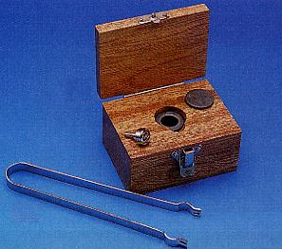
YOU WILL NEED
A Geiger tube, lead and stand
A source holder
A beta source (usually strontium 90, 185 kBq)
A set of aluminium absorbers
Tweezers
A ratemeter (or scaler and stopwatch)
A micrometer screw gauge
A ruler
A radioactivity warning sign

WHAT TO DO
Set up the apparatus as shown in the diagram and display the warning sign on your bench. The Geiger tube should be at a fixed distance from the source and this distance should not be altered during the experiment.

Record the count rate (I_{o}) with no absorber present

Use a pair of vernier calipers or a micrometer screw gauge to record the thickness (x) of one of the absorbers and then place it in the holder.

Record the count rate (I).

Repeat the experiment for the whole set of absorbers. Plot a graph of log I against absorber thickness (x).

Determine the absorption coefficient (μ) for aluminum from your graph and the equation:
ln I = ln I_{o} - μx

This sheet is for the teacher and technician only

Apparatus required:

Geiger tube
Source holder, lead and stand
Beta source (strontium 90)
Aluminium absorbers (set of mixed)
Tweezers
Ratemeter (or scaler and stopwatch)
Micrometer screw gauge
A ruler
A radioactivity warning sign

Comment on the experiment:
Stress the need for safety.
Tell the students to use the tweezers when handling the sources.

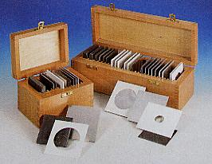

The photographic images are the copyright of Philip Harris Education and no part of them may be reproduced, photocopied or stored in any data retrieval system without permission.

