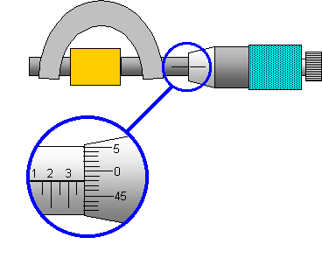
Micrometer
2
3
1
0
45
5

