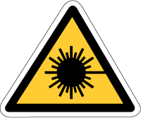
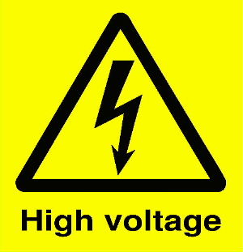
Warning symbols
Laser light
Eye protection advised
Eye protection advised
This experiment must only be done in a laboratory by your teacher.

